ASSESSING THE IMPACT OF CLIMATE WARMING ON ELKHORN CORAL (ACROPORA PALMATA) ON HORSESHOE REEF IN THE FLORIDA KEYS
By
MARI ELLA BOURBONNAIS

ABSTRACT
Coral reefs are rapidly declining due to climate change, with rising sea surface temperatures driving widespread bleaching events threatening reef ecosystems. This study investigates the relationship between coral surface area and bleaching intensity over time in Acropora palmata, a key reef building species in the Florida Keys. Although previous work has documented coral bleaching trends, new research is needed using non-invasive ways to quantify bleaching severity. This research uses image-based monitoring approach using photogrammetry and AI-powered segmentation to track changes in coral condition over three time points. Using photomosaics generated from underwater surveys and image analysis I calculated the 3D surface area and median red, blue and green pixel intensity as a proxy for 11 coral colonies to assess bleaching severity. Results show a significant increase in red and green pixel intensity over time, indicating a strong effect of time on bleaching severity, while surface area had no significant effect across time points. These findings highlight the potential of advanced image analysis techniques for long-term coral monitoring.

ASSESSING THE IMPACT OF CLIMATE WARMING ON ELKHORN CORAL (ACROPORA PALMATA) ON HORSESHOE REEF IN THE FLORIDA KEYS
by
MARI ELLA BOURBONNAIS
BS, University of Georgia, 2024

A Non-Thesis Report Submitted to the Graduate Faculty of The University of Georgia in Partial Fulfillment of the Requirements for the Degree

MASTER OF SCIENCE

ATHENS, GEORGIA
2025

ASSESSING THE IMPACT OF CLIMATE WARMING ON ELKHORN CORAL (ACROPORA PALMATA) ON HORSESHOE REEF IN THE FLORIDA KEYS

Major Professor: Dr. Patricia Yager
Committee members: Dr. James Porter
Dr. James Nelson

Signature

Dr. Patricia Yager

Dr. James Porter

Dr. James Nelson

ACKNOWLEDGEMENTS

I would like to thank Drs. Patricia Yager, and Jimmy Nelson for their guidance and mentorship throughout this research internship. I am especially thankful to Dr. James Porter for welcoming me onto the research team and providing a wide range of scientific diving opportunities that greatly enriched my experience. I am deeply appreciative of Camilla Nivison, whose continuous support and guidance was influential throughout the project. I would also like to thank Christa May and Shannon Shotz for their assistance with photo sorting and data organization. This research was made possible through funding from the National Science Foundation (NSF 21-502): Collaborative Research: CoralReef3D – An open-source toolkit for underwater 3D ecosystem modeling and analysis.

TABLE OF CONTENTS
Page
ACKNOWLEDGEMENTS 4
INTERNSHIP 6
Experience 6
Impact and Contribution 8
RESEARCH 8
Introduction 9
Methods 13
Results 15
Discussion 18
Conclusion 20
Reflection 20
REFERENCES 22

INTERNSHIP
Experience
The master’s research internship at the University of Georgia’s Marine Science Department took place from May 2024 to the present focused on contributing to NSF-funded research project examining Acropora palmata (elkhorn coral) in Key Largo, Florida. This internship consisted of two components: scientific diving fieldwork and data analysis. During the fieldwork portion which took place in May 2024 and again from July to August 2024, I participated in scientific diving activities to collect data for the project. Underwater photo transects were collected for image analysis and water samples were collected for microbial analysis. Using Nasco Whirl-Pak bags, water was sampled at three depths (surface, mid-depth, and bottom. Additionally, I participated in compass and bearing measurements taken for under water mapping (Figure 1) and coral reef rugosity to measure the 3D structure of the reef ecosystem. Compass and bearing measurements were taken by stretching a taut transect line across the reef and using a compass to record the direction of the line relative to magnetic north (Figure 1). Rugosity was measured by stretching a taut line across the reef and draping a small-link chain underneath, allowing it to follow the natural contours of the reef and providing a quantitative measure of its topographical complexity. This hands-on fieldwork provided valuable experience in underwater data collection and familiarized me with the tools and techniques necessary for studying coral reefs in their natural environment.
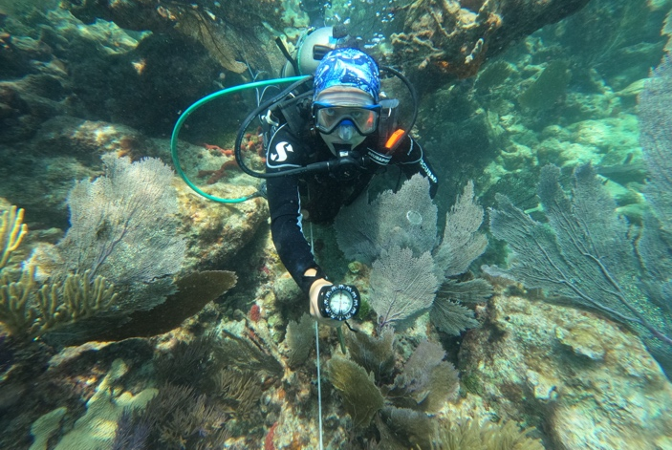
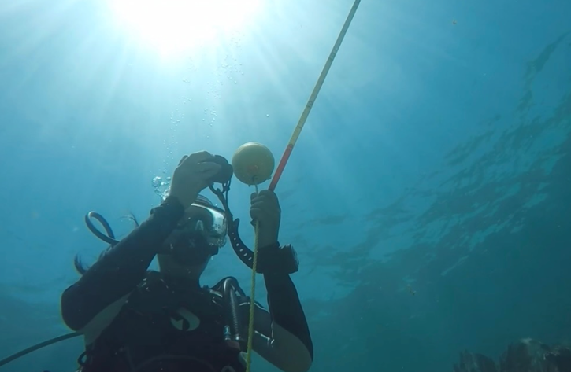
Figure 1: Compass and Bearing measurements taken on Horseshoe Reef (Photograph by Ella Bourbonnais and Dr. James Porter)
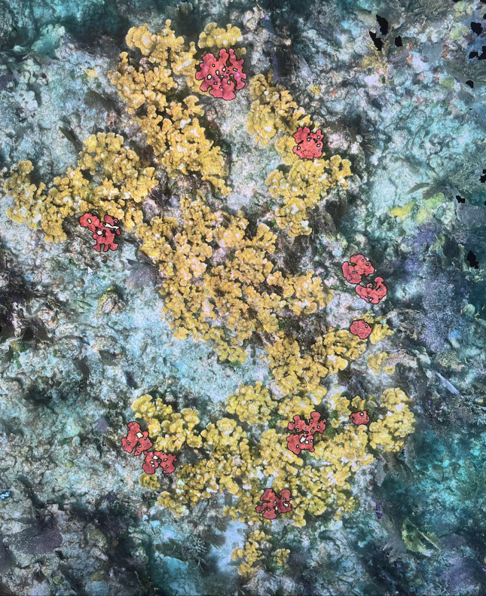
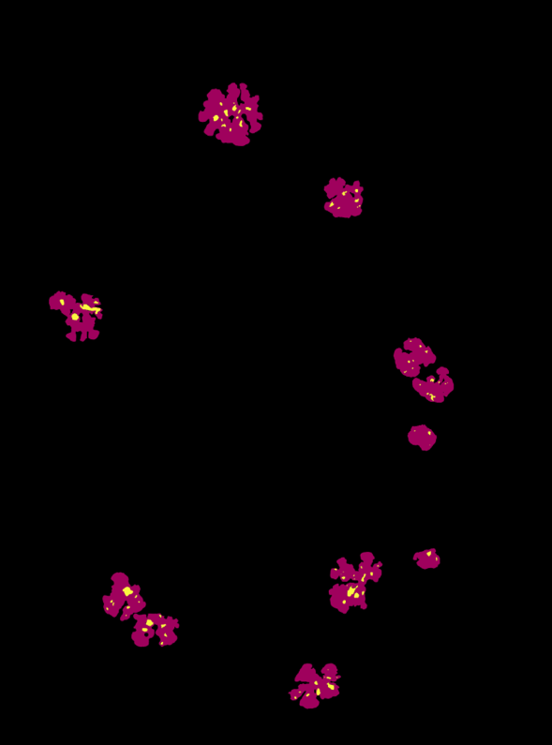
The second phase of the internship involved image analysis. This included utilizing Agisoft Metashape (Agisoft 2019) for photogrammetry, a software to visualize 3D models of the coral reef structures, as well as TagLab (Pavoni et al. 2021), an AI-powered segmentation software. My responsibilities included processing the data, analyzing the models and identifying trends related to the decline of A. palmata.
Figure 2: Orthomosaic from July 25,2023 on Horseshoe Reef generated using a digital elevation model and photo mosaics processed through Agisoft Metashape and TagLab. The left shows the orthomosaic segmented A. palmata and White Pox lesions and the right is the mask created.
The combination of field and computational work allowed me to develop a well-rounded skill set in scientific diving, underwater photography, and data analysis. Through this internship, I gained a deeper understanding of coral reef ecosystems, learned to identify coral species, and became proficient in using specialized software to analyze environmental data. This internship not only enhanced my technical skills but also contributed to the overall success of the NSF-funded project aimed at advancing coral conservation and monitoring through image analysis.
Impact and Contribution
The internship made significant contributions to the NSF-funded research project focused on understanding the decline of A. palmata and assessing the health of coral reef ecosystems in Key Largo, Florida. My involvement in both fieldwork and data analysis contributed valuable data collection, analysis, and the advancement of coral conservation efforts.
In the field, my participation in scientific diving and underwater data collection played a key role in expanding the project’s dataset. We were able to measure rugosity for eight monitoring plots on Horseshoe Reef, as well as taking one-second time lapse photo transects at the eight monitoring plots. The rugoisty and photo transects are valubale data that can be used to track changes in reef complexity and habitat availability.
Overall, my internship experience had a measurable impact on the project by expanding the field data collection, improving the analysis of coral reef ecosystems, and contributing to the development of advanced technologies for reef monitoring. Furthermore, my contributions helped to build a stronger understanding of the specific threats facing A. palmata and other coral species, providing essential data for informed conservation strategies and future reef management initiatives.
RESEARCH
INTRODUCTION
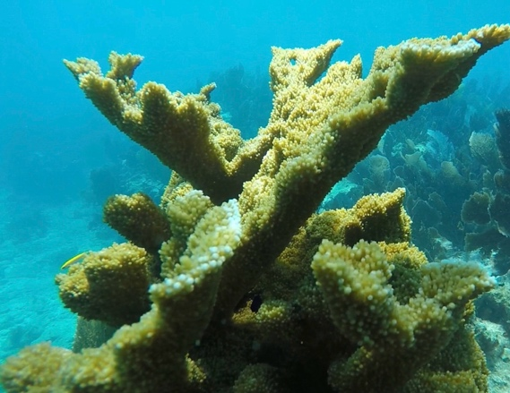
Coral reefs are among the most biologically diverse ecosystems on Earth, occupying less than 0.1% of the global ocean surface, yet supporting more than 25% of marine biodiversity (Bellwood et al. 2004). Additionally, corals reefs provide valuable ecosystems services such as protecting coastlines from erosions and storms (Ferrario et al. 2014). Coral species, such as Acropora palmata, are essential for reef building. They provide structural complexity and create habitats for a variety of marine species (Fisheries, 2024). Being bio-indicators of water and temperature changes, the health of the corals ​directly​ relates ​to the health​ of a reef ecosystem (Marín, 2023). The ability of corals to build reefs by secreting a hard, calcium carbon exoskeleton makes them a diverse habitat for a wide range of marine species (Yuan et al. 2024). The elkhorn coral, A. palmata (Figure 3), were once the most abundant shallow-water reef building corals in the Caribbean and the Florida Keys (Goreau 1959).

Figure 3: Living A. palmata (Photograph by Ella Bourbonnais)
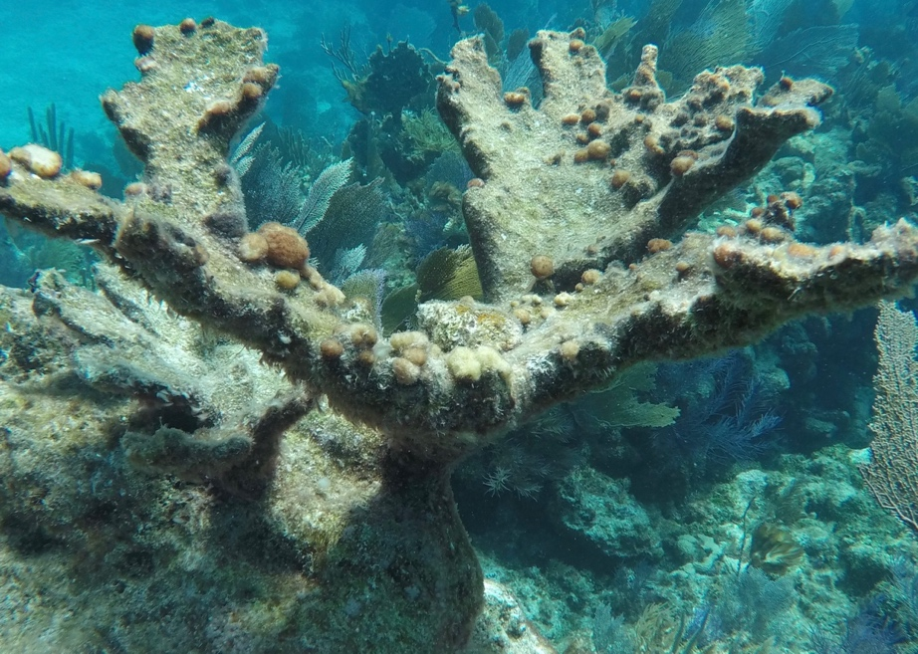
In the Caribbean, particularly the Florida Keys, the rising sea surface temperature (SST) have become a significant concern. The region has witnessed an alarming increase in SSTs in recent decades, surpassing the threshold that triggers coral bleaching events (Fisheries 2023). Climate change and local stressors have disrupted the symbiotic relationship between stony corals and their algal endosymbionts causing coral bleaching (Roth 2014). This phenomenon occurs when corals expel their Symbiodiniacea spp., which occurs in response to stress from elevated temperatures (Helgoe et al. 2024). Coral bleaching results in a loss of color (Figure 4) and diminished energy production (Woesik et al. 2022). The symbiotic relationship is a crucial partnership where the Symbiodiniaceae spp. photosynthetically fixes inorganic carbon, assimilate environmental nitrogen and provide organic nutrients to the coral host (Muscatine 1990). Thus, the symbiosis among corals and Symbiodinium supports coral metabolic requirements for growth, skeletal formation and production (Muscatine 1981). However, climate change can disrupt this delicate balance between the coral host and Symbiodiniaceae spp. (Sun et al. 2024). Climate warming is inhibiting coral resilience and survival leaving them vulnerable to additional stressors such as disease, predation, and poor water quality.

Figure 4: Dead A. palmata taken at Horseshoe Reef July 28th, 2024 (Photograph by Ella Bourbonnais)

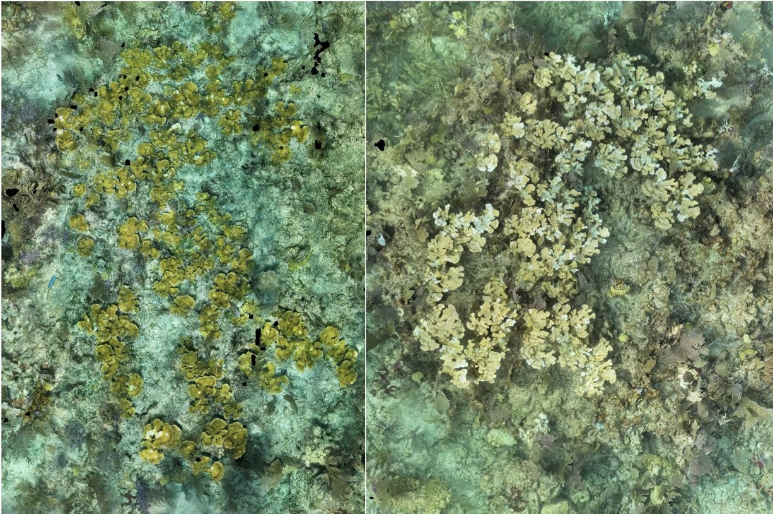
The Florida Keys is a crucial hotspot for marine biodiversity. The Florida Keys National Marine Sanctuary Advisory Council has identified Horseshoe Reef as high-priority site for conservation and study due to the biodiversity and connectivity to other habitats (Fisheries 2022). It is a small cluster of isolated patch reefs aggregated in a horseshoe shape. This reef was once some of the largest, healthiest elkhorn but is now threatened by compounding stressors (NOAA 2021).
Figure 5: Orthomosaic of monitoring plot 2 on Horseshoe Reef generated using a digital elevation model and photo mosaics processed through Agisoft Metashape. Photo 1 (July 12, 2022) and Photo 2 (July 25, 2023) illustrate the progression of coral bleaching over a one-year period.

Traditional methods of monitoring coral reefs, such as visual assessments through photographs have provided a valuable insight into coral health. However, these approaches are often subjective making it difficult to assess the true severity of bleaching events. A more detailed assessment method to assess coral health is vital for long-term monitoring of the health of A. palmata and other coral species. Quantifying bleaching intensity goes beyond simple visual assessment in photographs, enabling more precise and objective measurements of coral health and the severity of bleaching events (Chow et al. 2016). Employing advanced technologies such as orthomosaic and photogrammetry methods enable the generation of high-resolution, spatially accurate maps of reef surfaces. This allows scientists to process larger amounts of imagery and facilitate better understanding of habitat changes in coral reefs over time (Pavoni et al. 2024). These techniques. Which allow for monitoring of coral health, offer a promising approach for obtaining accurate, large-scale data on coral populations. This information could be crucial for informing conservation and restoration strategies.
Pixel saturation, a measurement of color intensity within digital images, serves as a proxy for coral bleaching severity. RGB imaging, which stands for Red, Green and blue refers to a method of capturing images based on the three primary colors of light. When applied to coral systems, RGB imaging can be used to monitor coral health by analyzing color variations on the coral’s surface. When combined with three-dimensional reconstructions of coral systems using photogrammetry, RGB imaging can provide a more comprehensive analysis. This 3D model can then be used to estimate the surface area of the coral structure. By quantifying the surface area of coral colonies, we can track changes in coral size and health (Teague et al. 2022). The primary objective of this study is to quantify bleaching intensity over time using pixel color saturation data. A secondary objective is to examine the relationship between coral colony surface area and bleaching intensity. It is hypothesized that coral colonies exhibiting greater surface area will show higher variability in bleaching intensity over time. Additionally, it is expected that overall bleaching severity will increase throughout the three-year study period. Furthermore, it is hypothesized that the red and green pixel color values will increase over time in response to bleaching. Given the ongoing threats to coral reefs globally, particularly in the Florida Keys, long-term, non-invasive monitoring methods are essential. This study contributes to those efforts by exploring the utility of digital tools in tracking coral bleaching dynamics at Horseshoe Reef, ultimately supporting targeted conservation and restoration strategies.
METHODS
Study Site
All fieldwork was performed on Horseshoe Reef (25.139736, -80.29431) located five miles off the coast of Key Largo Florida. It is a small cluster of isolated patch reefs aggregated in a horseshoe shape with an approximate depth of 10-20 feet.
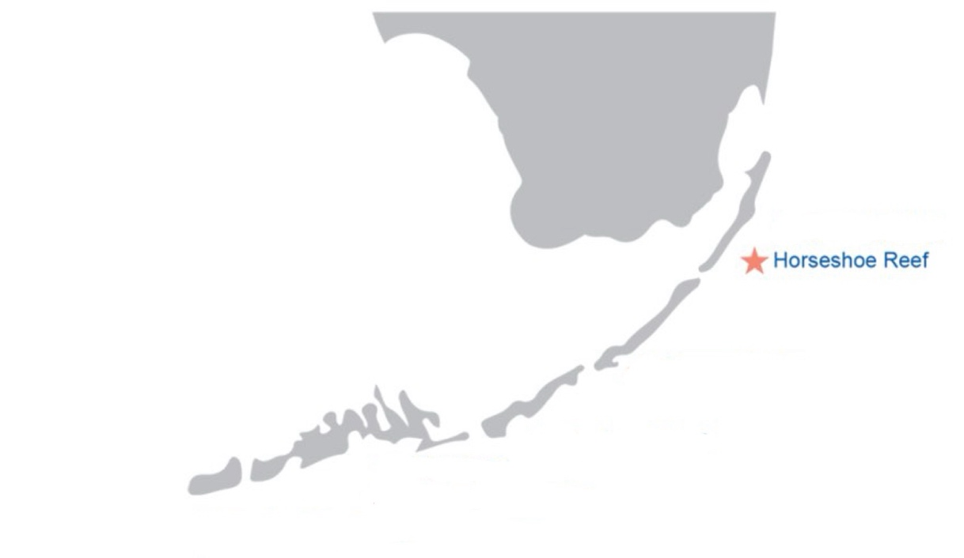
Figure 6: Map showing the location of Horseshoe Reef (NOAA 2021).

Field Work
A. palmata data were collected using long-term photographic surveys by divers under SCUBA. Images were taken simultaneously with two downward facing GoPro Hero 10 cameras attached to a PVC frame, capturing every second, by swimming back and forth across the monitoring regions. The start of the run was marked with a close-up of a numbered tile, and a hand covering the lens indicating a change in the swim pattern direction.
Photomosaics
All images were manually sorted. The photos from each time point (Table 1) were uploaded into Agisoft Metashape (Agisoft 2019) and aligned using high quality settings. If alignment issues arose, medium quality was attempted. If any photos were not aligned, they were not used.
Table 1: Table of the number of photos used within each time point
Time Point | Number of Photos
07.12.2022 | 1208/1244
07.11.2023 | 812/818
07.25.2023 | 924/924
.
A dense point cloud was generated using medium quality settings. Scaling markers were identified and labeled to define scale bars. The scale bars were set based on predefined objects, including rods (0.30 m), ping pong ball diameter (0.03 m) and tiles (0.15 x 0.15 m). A digital elevation model (DEM) was built using local coordinates and dense point cloud source data. The orthomosaic was then constructed using the DEM. A bounding box was drawn for the orthomosaic including all A. palmata within the image ensuring complete coverage and the area of the mosaic within the box was exported for further analysis.
Image Analysis
TagLab, a beta software program for benthic coral reef image analysis (Pavoni et al. 2021), was used to calculate the 3D surface area and perimeter for 11 focal coral colonies. The coral outlines were traced using the selection tool. The annotations were applied to classify A. palmata as a predefined label dictionary for classification. The White Pox disease lesions associated with each colony were tracked through time. The total coral surface area was determined using the DEM-based surface area calculation tool.
Statistical Analyses
To assess temporal changes in coral bleaching severity, pixel intensity values were used as a proxy for bleaching, with higher RBG component values (range: 0-255) indicating greater bleaching. A Kruskal-Walli’s rank sum test was used to evaluate differences in median red, green, and blue pixel intensity across three time points. Post hoc comparisons were conducted using Dunn’s test with Bonferroni correction to assess pairwise differences.
To examine how coral surface area influenced bleaching patterns over time, a linear mixed-effects model was fit using restricted maximum likelihood (REML), with surface area, time, and their interaction as fixed effects, and colony as a random effect to account for repeated measures. Model residuals and effect sizes were evaluated for fit and interpretation. All statistical analyses and data visualizations were performed in R statistical software version 4.4.1 (R Core Team 2024).
RESULTS

Red pixel intensity varied significantly over time (Figure 7). Median red pixel intensities increased across the three time points 2022-07-12, 2023-07-11, and 2023-07-25. A Kruskal-Walli’s rank sum test confirmed a statistically significant difference among the time points (H (2, N=33) = 26.96, p < 0.001). Post hoc Dunn’s tests with Bonferroni correction revealed that red pixel intensity was significantly higher on 2023-07-11 compared to 2022-07-12 (Z = -2.82, p = 0.0047), and significantly higher on 2023-07-25 compared to both 2022-07-12 (Z = -5.18, p < 0.001) and 2023-07-11 (Z = -2.36, p = 0.018). These results indicate a progressive and statistically significant increase in red pixel intensity over time, suggesting that coral colonies experienced increased bleaching between 2022 and 2023.

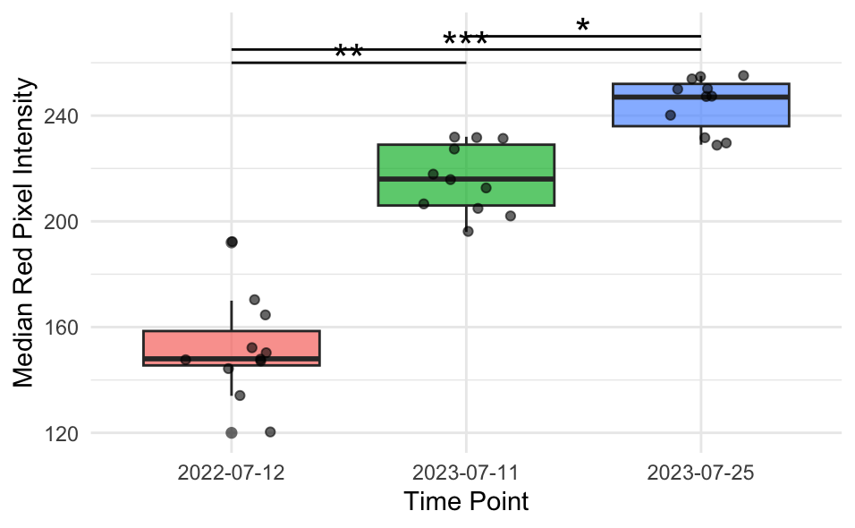
Figure 7: Boxplot of median red pixel intensity across three time points (2022-07-12, 2023-07-11, and 2023-07-25). Each box represents the interquartile range (IQR), with the median indicated by the horizontal line, and individual data points shown as jittered dots. A Kruskal-Walli’s test revealed a significant effect of time on red pixel intensity (H (2, N=33) = 26.96, p < 0.001) followed by Dunn’s post hoc tests indicated significant pairwise differences between all-time points (p < 0.05, p < 0.01, p < 0.001).
Green pixel intensity varied significantly across the three sampling time points (Figure 8). Median green values increased from 2022-07-12 to 2023-07-25, reflecting progressive bleaching patterns. A Kruskal-Walli’s rank sum test confirmed a statistically significant difference among time points (H (2, N=33) = 26.93, p < 0.001. Post hoc Dunn’s tests with Bonferroni correction showed that green pixel intensity was significantly higher on 2023-07-11 compared to 2022-07-12 (Z = -2.36, p = 0.018), and significantly higher on 2023-07-25 compared to both 2022-07-12 (Z = -5.18, p < 0.001) and 2023-07-11 (Z = -2.82, p = 0.0048).These results suggest a clear and statistically significant increase in green pixel intensity over time, further supporting the interpretation of increasing coral bleaching between 2022 and 2023.
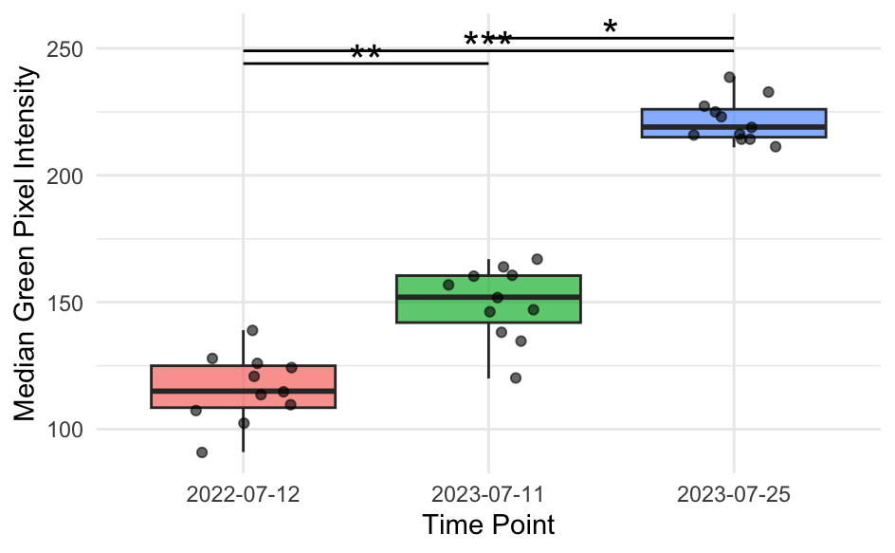
Figure 8: Boxplot of median green pixel intensity across three time points (2022-07-12, 2023-07-11, and 2023-07-25). Each box represents the interquartile range (IQR), with the median indicated by the horizontal line, and individual data points shown as jittered dots. A Kruskal-Walli’s test revealed a significant effect of Time on green pixel intensity (H (2, N=33) = 26.93, p < 0.001) Dunn’s post hoc tests indicated significant pairwise differences between all-time points (p < 0.05, p < 0.01, p < 0.001).

The relationship between coral surface area and red pixel intensity was evaluated across three time points (Figure 9). Each point represents an individual observation, with separate linear regression lines fitted for each time point. Time had a statistically significant effect on median red pixel intensity (p < 0.001), indicating an overall increase in bleaching severity over time. However, neither surface area (p = 0.84) nor the interaction between surface area and time (p > 0.1) showed a statistically significant effect. This suggests that changes in red pixel intensity were driven more by temporal factors than by colony size.

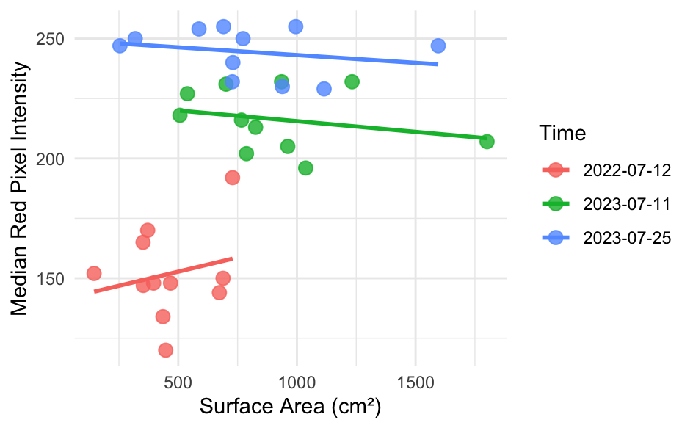
Figure 9: Relationship between surface area and median red pixel intensity across time points. Points represent individual observations, with separate regression lines fit for each time point. Time had a significance effect on red pixel intensity (p<0.001), while surface area and interaction terms were not statistically significant.
DISCUSSION
In this study, I investigated temporal changes in coral bleaching using RBG pixel intensity values as a proxy for bleaching severity. Results from statistical test revealed significant increase in red and green median pixel intensities across the three observed time points, suggesting a progressive bleaching response over time. The use of RBG values as a proxy, particularly the red pixel intensity demonstrated effectiveness in quantifying coral bleaching dynamics.
These findings are further supported by previous research, such as Erik et al. (2024), which found that red pixel intensity is strongly correlated with symbiont cell density and chlorophyll concentration in Acropora muricata. Given the close phylogenetic relationship between A. muricata and A. palmata, this strengthens the interpretation that using red pixel values in this dataset reflect increased bleaching severity. Thus, median red pixel intensity appears to be a reliable indicator of bleaching in A. palmata as well.
In additional to temporal trends, I evaluated the role of coral surface area in mediating bleaching severity. Time had a significant effect on red pixel intensity, whereas surface area and the interaction between surface area and time were not statistically significant. This suggest that while bleaching progressed over time, the physical size of the colony was not a major factor influencing median red pixel intensity within the time frame. This result is consistent with previous research, such as Hoogenboom et al. (2017) where no significant relationship was found between colony size and bleaching severity in Acropora species ranging from 5-90 diameter.
Although RBG-based image analysis provides a non-invasive method for monitoring bleaching, limitations remain. Underwater imagery is subject to environmental variables such as light attenuation which can influence pixel intensity. Future research should expand the sample size and include greater number of individual coral colonies to assess potential patterns that may not be detectable in this smaller dataset. Specifically, tracking more colonies over time would help determine whether colony size plays a more substantial role in bleaching susceptibility. These results highlight the use of RBG component analysis as a tool to monitor bleaching patterns. By combining image-based methods with ecological data, researchers can build a more accurate and comprehensive understanding of coral responses to climate-related stressors.
CONCLUSION
The framework for quantifying coral bleaching presented in this study offers a valuable, non-invasive approach to enhance long-term monitoring of coral reef ecosystems. Given the physical and ecological complexity of coral reefs, advanced imaging techniques such as photogrammetry and AI-based segmentation provide a powerful new tool set for assessing overall reef health. As coral reefs continue to undergo rapid changes globally, this research contributes to accelerating the pace of discovery and supports the development of data-driven solutions for coral conservation and restoration. This work directly aligns with the goals of the NSF-funded project and represents a meaningful step forward in advancing coral reef science and expanding global reef survey capabilities.
REFLECTION
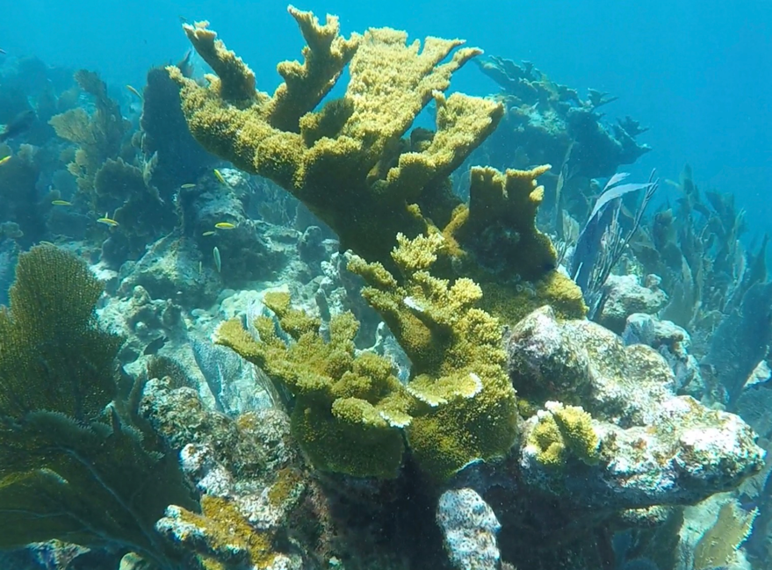
As an undergrad, my interest in scientific diving led me to pursue coral reef ecology allowing for an immersive, hands-on exploration of marine ecosystems. This internship through the Odum School of Ecology and the Marine Science department at the University of Georgia was a pivotal experience allowing me to contribute to NSF-funded project. The opportunity to apply what I have learned in the scientific diving courses at UGA, and the coral reef and tropical marine invertebrate class allowed me to apply this knowledge to real world research. Through the fieldwork, I developed hands-on skills during extensive underwater data collection that will help in my future of science diving. Additionally, I learned new analytical abilities through working with new AI-powered software. One of the most impactful moments for me was realizing how vulnerable coral reefs truly are in face of climate change. On our last dive in July, I encountered living A. palmata for the first time (Figure 10). This moment was eye opening as for the entire summer research experience, I had only encountered dead A. palmata. This experience deepened my motivation to pursue a career in marine science. This internship has inspired me to continue pursuing coral reef research, with a strong focus on coral restoration, while also advancing my skills and experience in scientific diving.
Figure 10: Living A. palmata seen on July 31st, 2024. (photograph by Ella Bourbonnais)

REFERENCES

Agisoft. (2019). Metashape. http://www.agisoft.com/
Bellwood, ​D. R​., Hughes, T. P., Folke, C., & Nyström, M. (2004). Confronting the coral reef crisis. Nature, 429(6994), 827–833. https://doi.org/10.1038/nature02691
Chow M.H., Ryan H.L. Tsang, Eric K.Y. Lam, P. Ang (2016) Quantifying the degree of coral bleaching using digital photographic technique, Journal of Experimental Marine Biology and Ecology, Volume 479, Pages 60-68, ISSN 0022-0981, https://doi.org/10.1016/j.jembe.2016.03.003.
Erik Francesco Ferrara, Lavinia Bauer, Giulia Puntin, Friederike Bautz, Sibel Celayir, Marie-Sa Do, Frederik Eck, Melissa Heider, Pia Wissel, Angelina Arnold, Thomas Wilke, Jessica Reichert, Maren Ziegler. (2024). RGB color indices as proxy for symbiont cell density and chlorophyll content during coral bleaching. bioRxiv 2024.12.20.629333; Doi: Https://Doi.Org/10.1101/2024.12.20.629333.
Ferrario, F., Beck, M. W., Storlazzi, C. D., Micheli, F., Shepard, C. C., & Airoldi, L. (2014). The effectiveness of coral reefs for coastal hazard risk reduction and adaptation. Nature Communications, 5(1), 3794. doi:10.1038/ncomms4794
Fisheries, N. (2022). Restoring seven iconic reefs: A mission to recover ​the coral reefs of the Florida Keys. https://www.fisheries.noaa.gov/southeast/habitat-​​conservation/restoring-seven-iconic-reefs-mission-recover-coral-reefs-florida-keys​
Fisheries, N. (2023) Extreme Ocean temperatures are affecting Florida’s Coral Reef. https://www.nesdis.noaa.gov/news/extreme-ocean-temperatures-are-affecting-floridas-coral-reef
Fisheries, N. (2024). ​Elkhorn Coral.​ ​https://www.fisheries.noaa.gov/species/elkhorn-coral​
Fisheries, NOAA. (11 Dec 2024) “Restoring Seven Iconic Reefs: A Mission to Recover the Coral Reefs of the Florida Keys.” NOAA, www.fisheries.noaa.gov/southeast/habitat-conservation/restoring-seven-iconic-reefs-mission-recover-coral-reefs-florida-keys.
Goreau TF (1959) The ecology of Jamaican coral reefs I. Species Composition and zonation. Ecology 40:67-90
Helgoe, J., Davy, S. K., Weis, V. M., & Rodriguez-Lanetty, M. (2024). Triggers, cascades, and endpoints: Connecting the dots of coral bleaching mechanisms. Biological Reviews, 99(3), 715–752. doi:10.1111/brv.13042
Hoogenboom, M. O., Frank, G. E., Chase, T. J., Jurriaans, S., Álvarez-Noriega, M., Peterson, K., Critchell, K., Berry, K. L. E., Nicolet, K. J., Ramsby, B., & Paley, A. S. (2017). Environmental drivers of variation in bleaching severity of Acropora species during an extreme thermal anomaly. Frontiers in Marine Science, 4, Article 376. https://doi.org/10.3389/fmars.2017.00376
Marín, R (2023) ​A. Benthic foraminifera as bioindicators of coral reef health​. Nat ​Rev Earth​ Environ 4, 733. https://doi.org/10.1038/s43017-023-00451-8
Mei-Hua Yuan, Kuan-Ting Lin, Shu-Yuan Pan, Chih-Kai Yang, (2024) Exploring coral reef benefits: A systematic SEEA-driven review, Science of The Total Environment, Volume 950, 175237, ISSN 0048-9697, https://doi.org/10.1016/j.scitotenv.2024.175237.
Muscatine, L. (1990) The role of symbiotic algae in carbon and energy flux in reef corals. Coral Reefs 25, 75–87
Muscatine, L., R. McCloskey, L. & E. Marian, R. (1981) Estimating the daily contribution of carbon from zooxanthellae to coral animal respiration. Limnol. Oceanogr. 26, 601–611
NOAA. (2021). Restoring seven iconic reefs: A mission to recover the coral reefs of the Florida Keys. https://www.fisheries.noaa.gov/southeast/habitat‐conservation/restoring‐seven‐iconic‐reefs‐mission‐recover‐coral‐reefs‐florida‐keys
Pavoni, G., Corsini, M., Ponchio, F., Muntoni, A., Edwards, C., Pedersen, N., Sandin, S., & Cignoni, P. (2022). TagLab: AI-assisted annotation for the fast and accurate semantic segmentation of coral reef orthoimages. Journal of Field Robotics, 39, 246–262. https://doi.org/10.1002/rob.22049
R Core Team (2024). _R: A Language and Environment for Statistical Computing_. R Foundation for Statistical Computing, Vienna, Austria.
Roth, M. S. (2014). The engine of the reef: photobiology of the coral–algal symbiosis. Front. Microbiol. 5, 422
Sun, Y., Sheng, H., Rädecker, N. et al. (2024) Symbiodiniaceae algal symbionts of Pocillopora damicornis larvae provide more carbon to their coral host under elevated levels of acidification and temperature. Commun Biol 7, 1528. https://doi.org/10.1038/s42003-024-07203-4
Teague, J., Megson-Smith, D. A., Allen, M. J., Day, J. C. C., & Scott, T. B. (2022). A Review of Current and New Optical Techniques for Coral Monitoring. Oceans, 3(1), 30-45. https://doi.org/10.3390/oceans3010003
Woesik, R. van, Shlesinger, T., Grottoli, A. G., Toonen, R. J., Vega Thurber, R., Warner, M. E., Marie Hulver, A., Chapron, L., McLachlan, R. H., Albright, R., Crandall, E., DeCarlo, T. M., Donovan, M. K., Eirin-Lopez, J., Harrison, H. B., Heron, S. F., Huang, D., Humanes, A., Krueger, T., Madin, J. S., … Zaneveld, J. (2022). Coral-bleaching responses to climate change across biological scales. Global change biology, 28(14), 4229–4250. https://doi.org/10.1111/gcb.16192

